# PROJECT REPORT TEMPLATE

1 INTRODUCTION

1.1 Overview

India is the world's third-largest producer and third-largest consumer of electricity. The usage of Electricity in increased by people.

Day-by-Day the electricity usage is increased because the growth of population. In 2019 and 2020 the electricity usage is increased. In the lockdown time from the

month of march to june the impact of lockdown on economic activities have been faced by every sector in a positive or negative ways. The usage of electricity consumption

is decreased in COVID-19 situation. we create a 16 tableau sheets , 3 Dashboard and 1 Story.

1.2 Purpose

The use of this project is we learn many things about our project .How the electricity consumption will increased and Decreased. We create a

knowledge about the electricity consumption. this project is very useful to us.

2 PROBLEM DEFINITION & DESIGN THINKING

2.1 Empathy Map

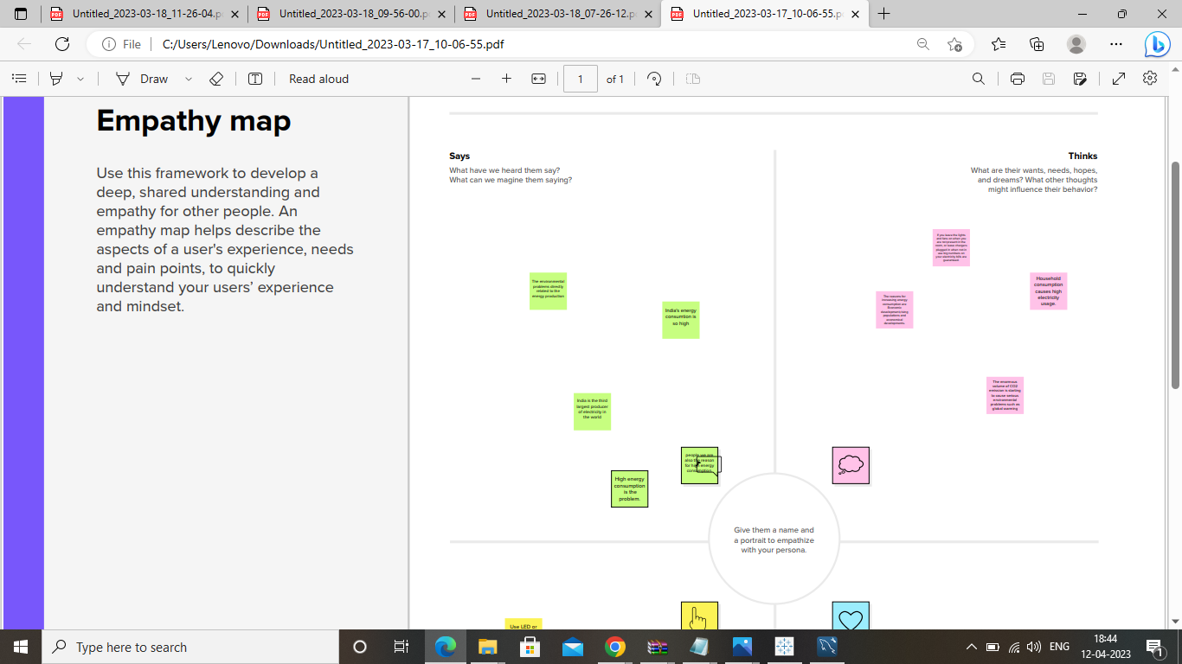

2.2 Ideation & Brainstorming Map

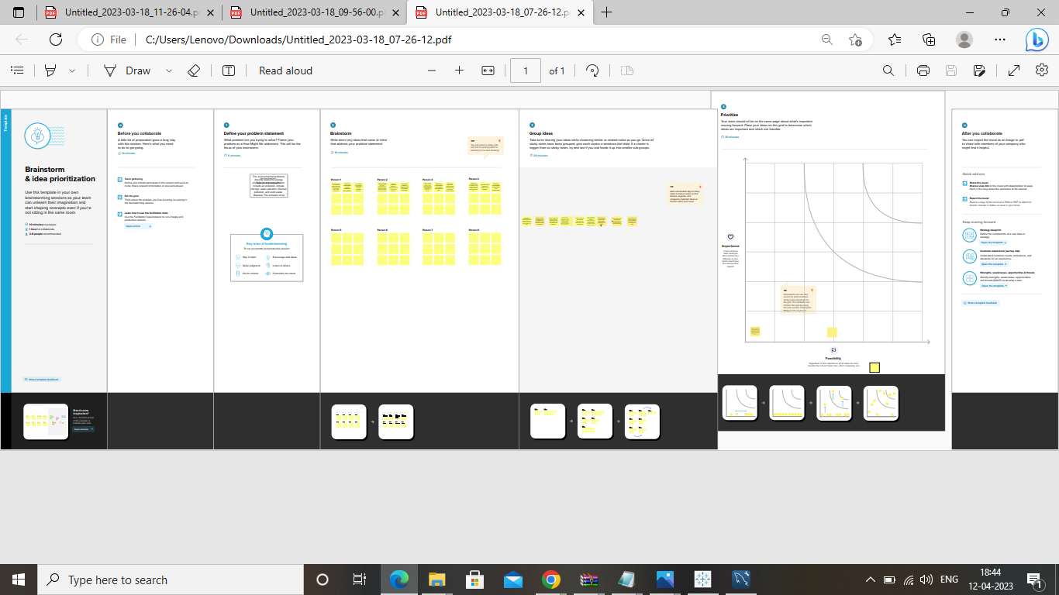

3 RESULT

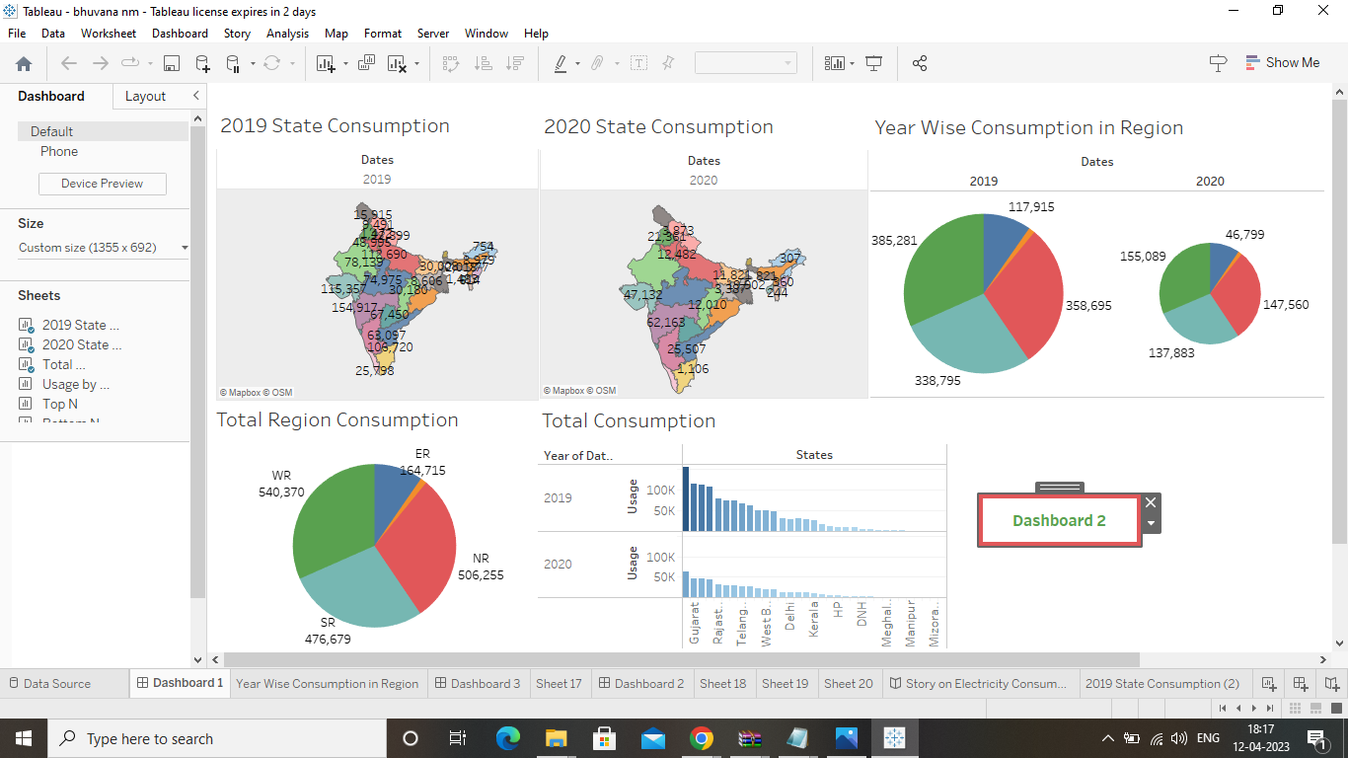

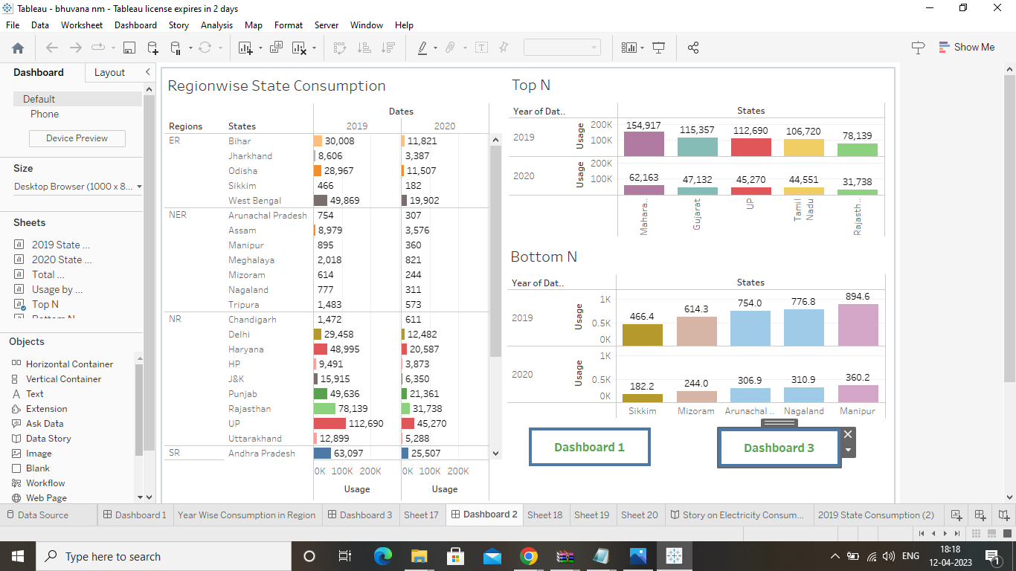

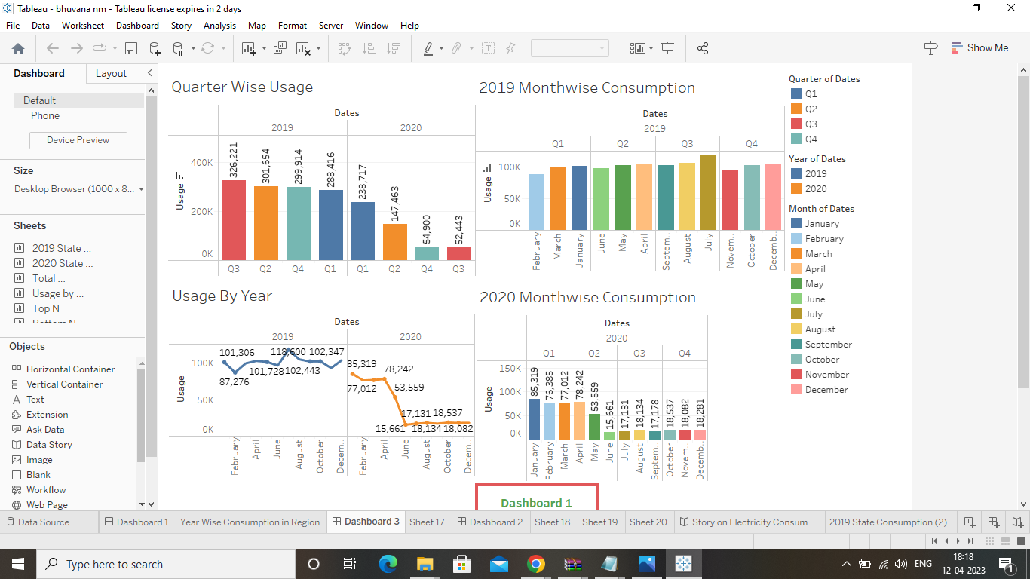

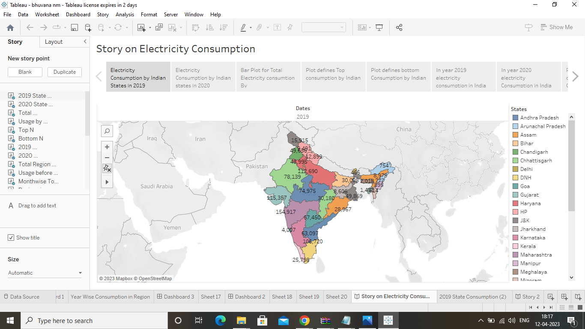

4 ADVANTAGES & DISADVANTAGES

Advantages:

1. Low maintenance cost

2. More efficient

3. It is renewable

Disadvantages:

1.Cost for construction

2.Sometimes messes up wildlife

3.More expansive than gasoline

5.APPLICATIONS

We have to solve this problems one by one where the solution is applicable .We have to give the solution where the usage of electricity consumption is high. And we have to control it by our solution.

6.CONCLUSION

In our project we make exclusive things . In Ideation & Brainstroming templates we create a things, dose ,feel, etc. In tableau we create maps as we like.

7.FUTURE SCOPE

By our project we hope that in future we control the electricity consumption. My next step in this project again we have to analysis what change was happen by this project among the electricity and what are the advantages and disadvantages are in our project. How can we over come the disadvantages of the project. Then what we have to change in our project to get the solution. After finding the solution we have to execute that in our project and get proper results.